|  |  |
| --- | --- |
| Canon EOS M50 Mark II (Black)  Máy ảnh Canon EOS M50 Mark II (Black) + Kit 15-45mm f/3.5-6.3 IS STM  canon-eos-m50-mark-ii-2 canon-eos-m50-mark-ii-5 canon-eos-m50-mark-ii-10 canon-eos-m50-mark-ii-9 | **Featured information:**DIGIC 8 image processorAPS-C 24.1MP CMOS sensorDual Pixel CMOS AF with Eye Detect AF Record UHD 4K and HD 720p120 video  Price : $ 700  **Specifications:**  Viewfinder Type  Electronic  Screen Characteristics  Articulating Touchscreen LCD  Screen Resolution  1,040,000 pixels  Screen Size  3.0"  Viewfinder Magnification  -  Viewfinder Coverage  100%  Viewfinder Size  0.39"  Viewfinder Resolution  2,360,000 pixels |

**Overview:**

With the purpose of serving vloggers and content creators. The Canon EOS M50 Mark II is a versatile, multimedia camera with a comprehensive photo and video feature set. Besides the ability to focus, remember and share images is improved. The M50 Mark II retains the 24.1 MP APS-C CMOS sensor and DIGIC 8 image processor allowing for fast shooting speeds of 10 frames per second.

APS – C 24.1MP CMOS sensor and DIGIC 8 image processor

Both a 24.1MP APS – C CMOS sensor and DIGIC 8 image processor are used to deliver high-sensitivity, fast camera performance suitable for still and video shooting. The ISO range spans from 100 – 25600 with an expandable setting of ISO 51200 suitable for a variety of lighting conditions.

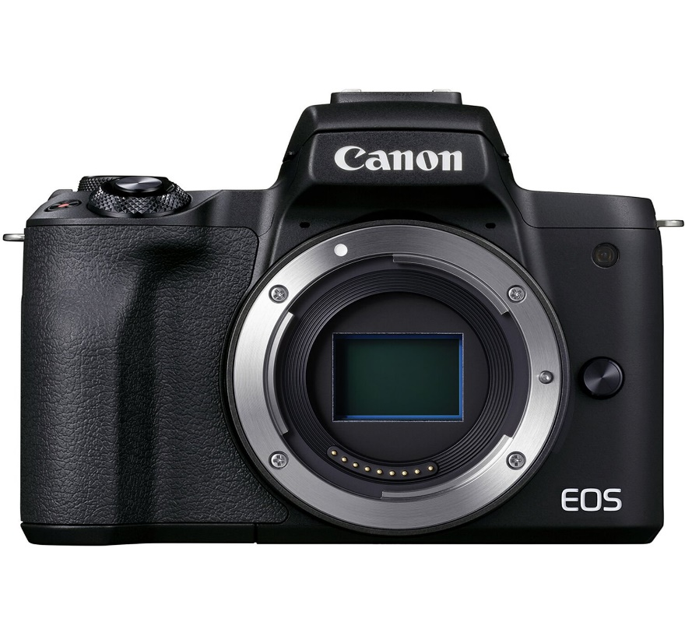

Ability to handle noise and automatically optimize clear lighting in different shooting situations. UHD 4K video recording, supporting 23.98 fps with Full HD 1080p60 and HD 720p120 settings for slow motion recording effect. Supports vertical video recording as well as HDMI port for live transmission of high-resolution frames. In addition, the processor has a shooting speed of 10 frames per second, fast startup time, and short time interval between each frame for efficiency in the shooting process.

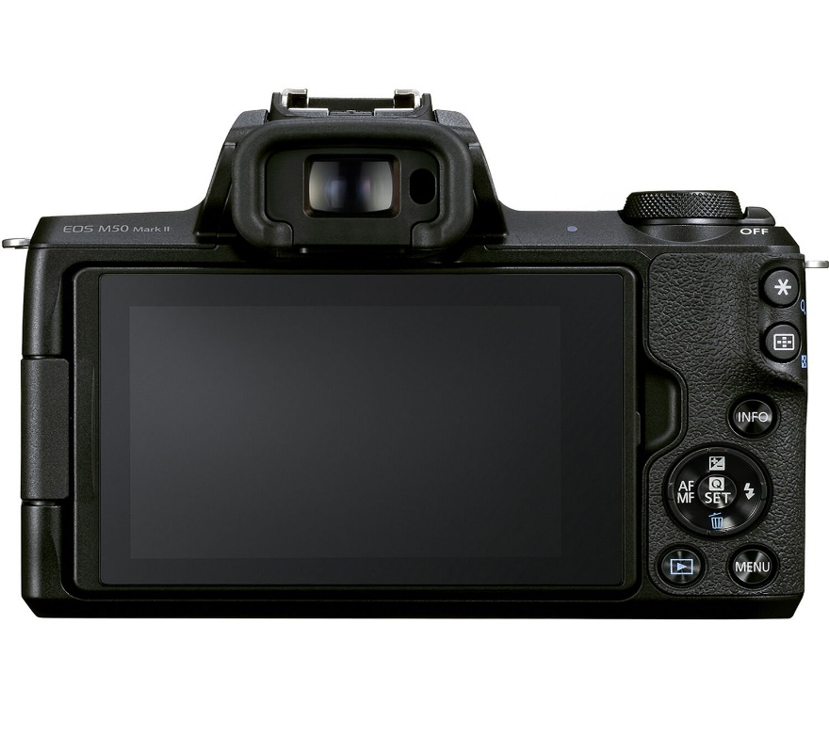

Movie Servo AF video recording mode is smooth, focusing naturally when changing between different subjects or at different distances within scenes. In addition, the touch AF system also allows you to focus easily by touching the touch screen to change the focus point.

Subject tracking on the M50 Mark 2 is also enhanced by the Dual Pixel CMOS AF system that helps identify subjects and maintain focus. In addition, Eye Detection AF can also be used with Movie Servo AF, and eye and face detection can use Servo AF modes to help keep your subject in focus.

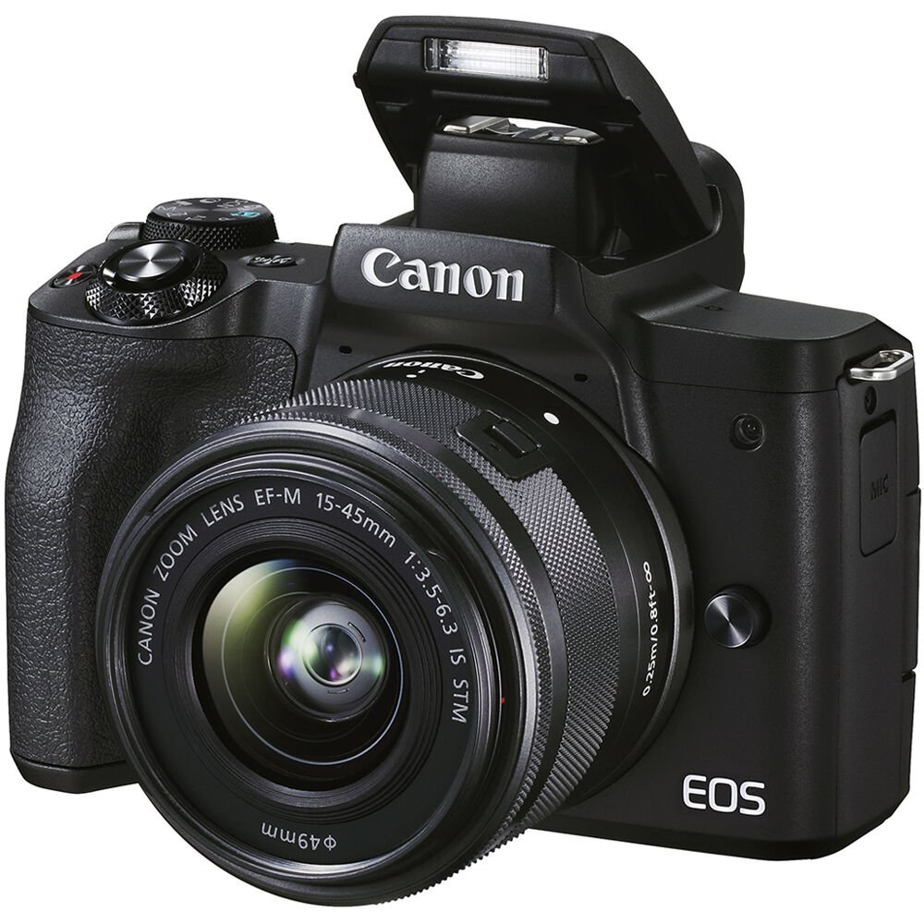

Optical image stabilization on the EOS M50 II helps reduce shake by up to 3.5 stops for sharp handheld photography. The STM motor provides smooth, nearly silent autofocus performance.